
Sydney Girls High School
2004
Preliminary Course Examination
Chemistry

1. The diagram below shows the relative abundances of elements in the lithosphere.

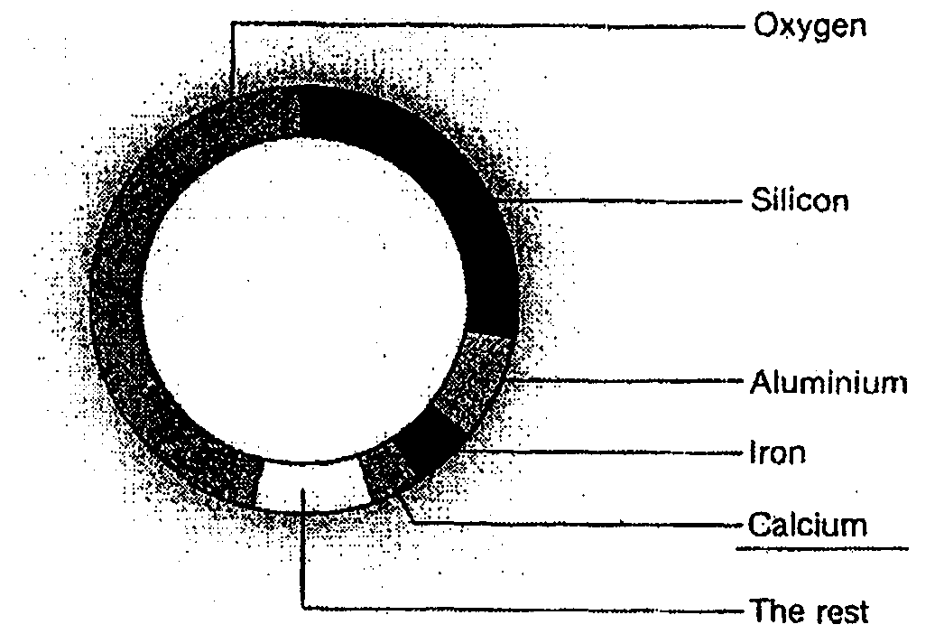

Which of the following statements is true?
(A) Metals are more abundant than non-metals in the lithosphere.
(B) Oxygen is commonly present as a gas in the lithosphere.
(C) Silicon is the most abundant non-metal in the lithosphere.
(D) Aluminium is the most abundant metal in the lithosphere.

2. Identify from the examples the reaction which represents a physical change.
(A) Decomposition of copper carbonate
(B) Condensation of water vapour
(C) Electrolysis of water
(D) Burning of Hydrogen

3. The flow chart below shows the extraction of zinc metal from the mineral sphalerite in four steps.

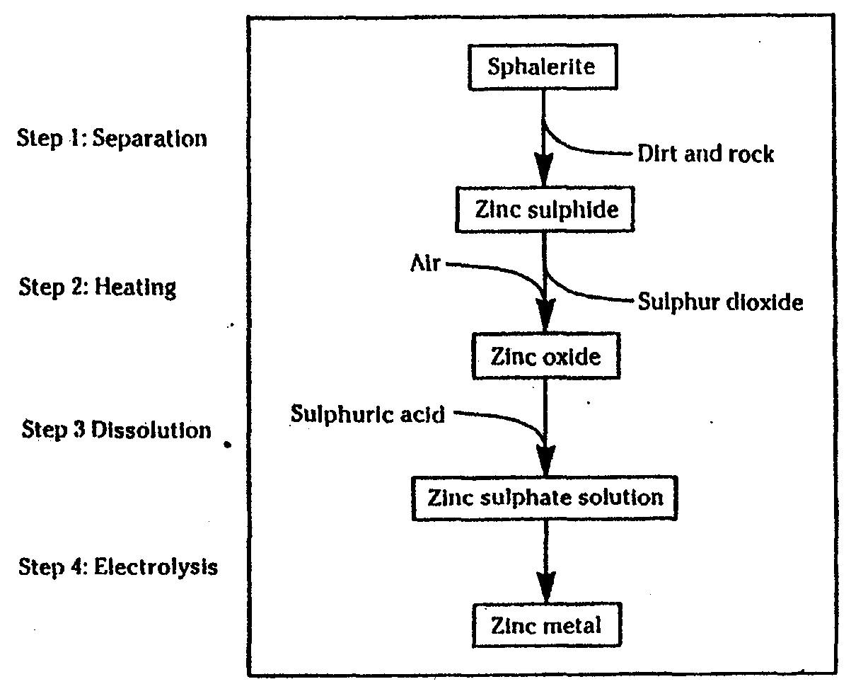
Which steps in this process are chemical changes and which steps are physical changes?

 | Chemical Changes | Physical Changes
A | Step 1 | Steps 2, 3 and 4
B | Step 1 and 3 | Steps 2 and 4
C | Steps 2 and 4 | Steps 1 and 3
D | Steps 2, 3 and 4 | Step 1

4. What is the third member of the homologous series known as alkenes?
(A) Propane (B) Butyne (C) Butene (D) Propene

5. The diagram below shows a graph of one trend among the elements in the periodic table.
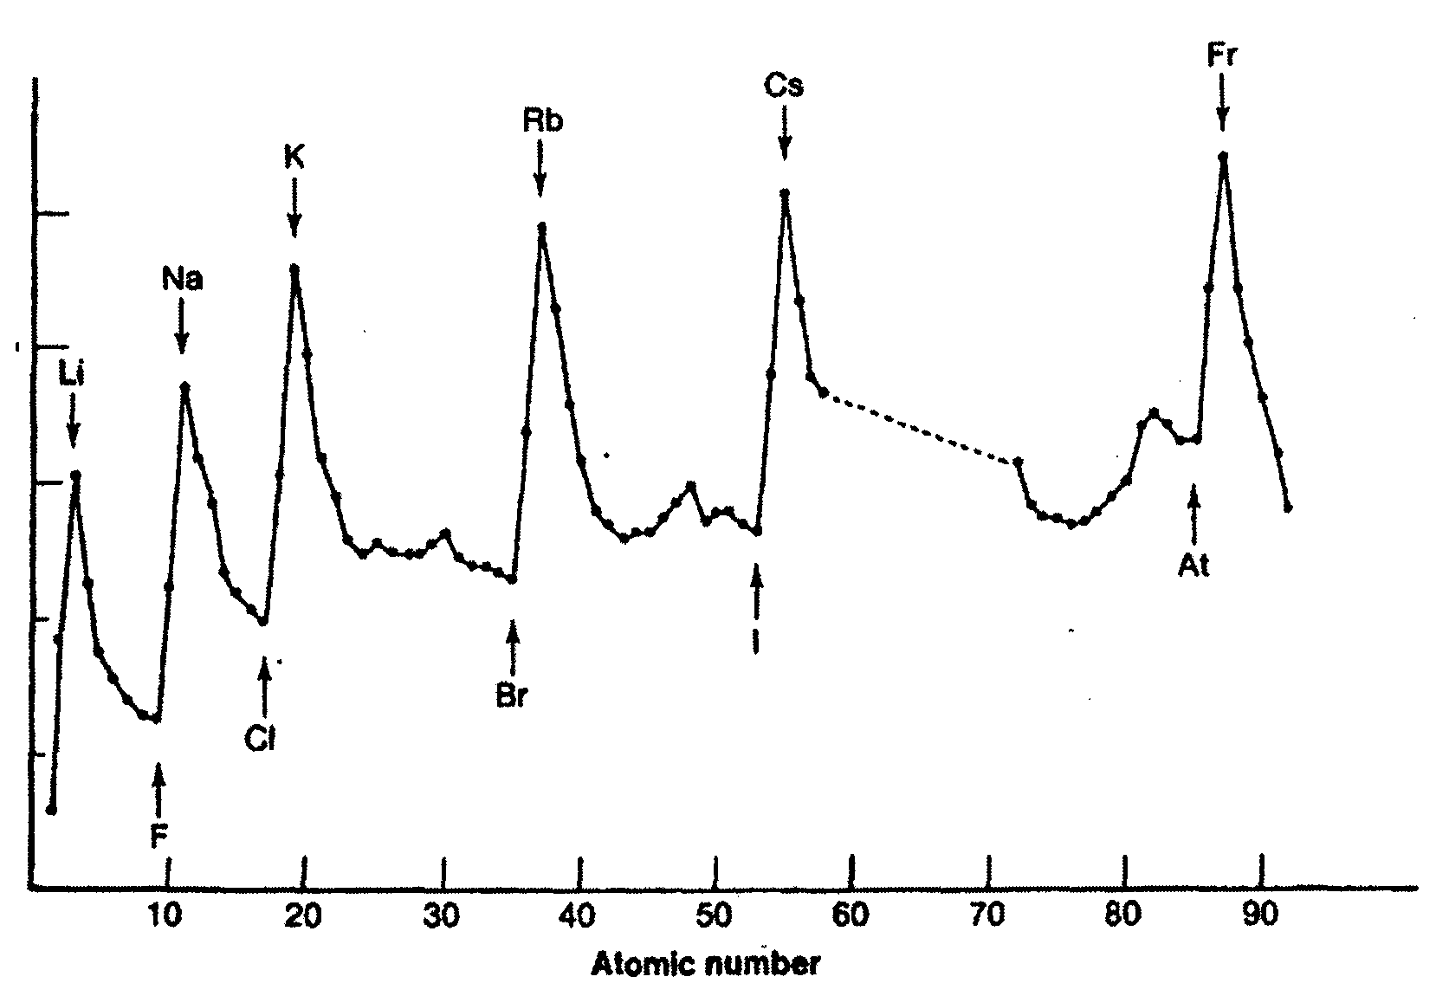

What trend is described by the graph?

(A) Atomic radius
(B) Density
(C) First ionization energy
(D) Melting point

6. Why is Aluminium recycled more than any other metal?
(A) Aluminium has a low density and high conductivity.
(B) Aluminium items corrode easily and have to be replaced often.
(C) Aluminium becomes coated with aluminum oxide which prevents corrosion.
(D) Aluminium requires less energy to be recycled than to be extracted from its ore.

7. What does a catalyst do in a chemical reaction ?
(A) Change the activation energy for the reaction.
(B) Increase the rate of the forward reaction only.
(C) Decrease the rate of the back reaction.
(D) Increase the enthalpy of the reaction.

8. The table below shows the melting point of four different chlorides.

Compound | Formula | Melting Point ( ºC)
hydrogen chloride | HCl | -114
nitrogen trichloride | NC1₃ | -27
silicon tetrachloride | SiCl₄ | -68
sodium chloride | NaCl | 801

Why does sodium chloride have a much higher melting point than the other three compounds?
(A) Sodium chloride has a greater molar mass than the other three.
(B) Sodium chloride is ionic while the other three are covalent molecular substances.
(C) The intermolecular forces are greater in sodium chloride than in the other three.
(D) The percentage of chlorine by mass is lower in the sodium chloride than in the other three.

9. In a saturated solution of sodium chloride the sodium chloride particles are

(A) leaving the crystals at a faster rate than they are returning to them
(B) leaving the crystals at the same rate that they are returning to them
(C) leaving the crystals at a slower rate than they are returning to them
(D) neither leaving the crystals nor returning to them.

10. Paraffin wax is a mixture of high molecular mass alkanes which is often used as a waterproofing agent because of its water repellant properties and its insolubility in water. It is applied to fabrics dissolved in the solvent 'Shellite'. From this information, it is reasonable to infer that 'Shellite'
(A) is soluble in water. (B) has a higher relative molecular mass than water.
(C) is more volatile than water. (D) is a non-polar solvent

11. In what way is the high specific heat of water significant to life on Earth ?

(A) Water can be readily boiled.
(B) Water can absorb large quantities of heat without a large temperature rise.
(C) Less heat is required to heat water I degree than to heat a liquid with a lower specific heat, such as alcohol.
(D) It is able to dissolve more oxygen on a hot day.

12. Why does a slight increase in temperature often causes a dramatic increase in the rate of a chemical reaction?
(A) Average frequency of the collisions between particles decreases.
(B) Orientation of colliding particles is now favourable.
(C) Activation energy for the reaction has decreased substantially.
(D) Number of molecules with energy greater than the activation energy increases substantially.

Part B ( 60 marks)

Question 13 ( 5 marks)
The properties of five substances are listed below

Substance | MP.  (°C) | B.P.  (°C) | Density  (g ml⁻¹) | Solubility in  water | Solubility in  octane
silicon dioxide | 1700 | 2230 | 2.6 | no | no
potassium iodide | 681 | 1324 | 3.1 | yes | no
naphthalene | 80 | 218 | 1.2 | no | yes
water | 0 | 100 | 1.0 | yes | no
octane | -95 | 111 | 1.5 | no | yes
Use the information in the table to answer the following questions
(a) Which two substances could be separated from each other using a separating funnel? [1]
(b) All of these substances were placed in a large test-tube, shaken up and then allowed to settle. Assume that the density of any solution is similar to that of the solvent.
Use a labelled diagram to show the composition of each layer. [2]
(c) Describe the steps necessary to separate the potassium iodide from the mixture in the test tube. [2]

Question 14 (6 marks)

Potassium has the electron configuration of 2,8,8,1 and Sulfur has the electron configuration 2,8,6.

(a) Write a half equation for each showing how the ions are formed in each case. [1]
(b) Identify the product formed when potassium reacts with sulfur to form an ionic compound and write its formula. [2]
(c) Predict the formula for the compound formed between Sulfur and X then identify the type of bonding present in the compound. [2]

Question 15 (6 marks )
A student performed the following experiment.
Small pieces of four different metals were added to cold water containing Universal Indicator and the results were recorded in the table shown.

Metal | Form | Gas Bubbles | Indicator Colour
calcium | large granules | Bubbles of colourless gas were given off vigorously. | Green to purple
magnesium | powder | Tiny bubbles appear on the surface | Green to purple
sodium | lump | Bubbles of gas were given off very vigorously. The gas ignited | Green to purple
zinc | small chips | No gas bubbles apparent | No change

metal + water metal hydroxide + hydrogen gas

(a) Write a balanced equation for the reaction of sodium. [2]
(b) Identify the substance being oxidized in (a) [1]
(c) Suggest why the indicator changes colour during the experiment. [1]
(d) A student concluded from ~er results the metal reactivity order from most to least reactive was : Sodium, Calcium, Magnesium and Zinc.
Assess the validity of her conclusion on the basis of experimental design. [2]

Question 16 ( 5 marks )
A student completely reacted some solid iron (II) sulfide in 200mL of 0.5 mo1L⁻¹ hydrochloric acid, forming iron (II) chloride in solution and collecting all the hydrogen sulfide gas produced. The volume of hydrogen was 122.5 mL. at room temperature (25°C) and pressure (100 kPa)
(a) Calculate the number of moles of hydrogen sulfide gas collected. [1]
(b) Write a balanced equation for the reaction. [1]
(c) Determine the mass of iron (II) sulfide used in the experiment. [2]
(d) Using a calculation, show that the amount of hydrochloric acid used was in excess. [1]

Question 17 (6 marks)

(a) Draw an electron dot diagram to represent a water molecule. [1]
(b) Identify and explain the shape of a water molecule. [1]
(c) Describe how models help explain the differing densities of liquid and solid water. [3]

Question 18 ( 6 marks)

Penny conducted a calorimetry experiment to determine the enthalpy changes due to the dissolution of sodium hydroxide in water.

In the experiment she weighed out exactly 1.00 gram of the solid sodium hydroxide onto a square of shiny paper. Using a burette she measured 50.0 mL of deionised water into a clean polystyrene foam cup (calorimeter) fitted with foam lid. She recorded the initial temperature, added the solid, replaced the lid and recorded the temperature every minute as shown in the table below. She stirred to dissolve the solid while recording the temperature.

Penny's Results

Sodium Hydroxide

Time (minutes) | Temperature (ºC)
0 | 21.3
1 | 23.2
2 | 24.7
3 | 26.0
4 | 25.3
5 | 22.9

(a) Use the calorimetry equation to calculate the quantity of heat absorbed or released on dissolution of the sodium hydroxide. Assume that the mass of solution is 50 grams and that the specific heat capacities, is 4.18 Jg⁻¹ K⁻¹.

(b) Calculate the number of moles of sodium hydroxide used and then calculate the molar enthalpy of solution for sodium hydroxide in water. [2]

(c) The published value for the enthalpy of solution of sodium hydroxide is -4l.6 kJ/mol.
Suggest two reasons for any difference between the experimental value and the published value. [2]

Question 19 (6 marks)

Though graphite and diamond are elemental substances of carbon, they show very different properties. Some of the differences are arrangement of the carbon atoms, hardness, melting point, boiling point, and electrical conductivity.
(a) Describe the arrangement of the carbon atoms in the two allotropes. [2]
(b) Identify the harder substance and explain why this substance is harder. [2]
(c) Graphite conducts electricity but diamond does not. Explain. [2]

Question 20 (7 marks)
A member of the homologous series, is homologous 2-butene.
(a) Draw the structural formula and write the molecular formula of 2-butene. [2]
(b) Calculate the molar mass of 2-butene. [1]
(c) Calculate the total number of atoms in a mole of 2 - butene. [2]
(d) Assess whether an isomer of 2 - butene would have the same empirical formula as 2 - butene. [2]

Question 21 (8 marks)

The following table lists some of the properties of three liquid hydrocarbons.

Straight-chain alkane | Flashpoint (°C) | Ignition temperature (°C) | Boiling point (°C)
pentane (C₅H₁₂) | -49 | 290 | 36
hexane (C₆H₁₄) | -22 | 248 | 69
heptane (C₇H₁₆) | -4 | 230 | 98

(a) Account for the trend in boiling points for the three hydrocarbons. [2]
(b) Explain why knowledge of the flashpoint rather than ignition temperature of fuels is more important in the safe storage of fuels. [2]
(c) Explain the relationship between flash point and boiling point for these fuels. [2]

Question 22 (2 marks)
Examine the graph showing the changes in chemical potential energy as hexane is combusted.

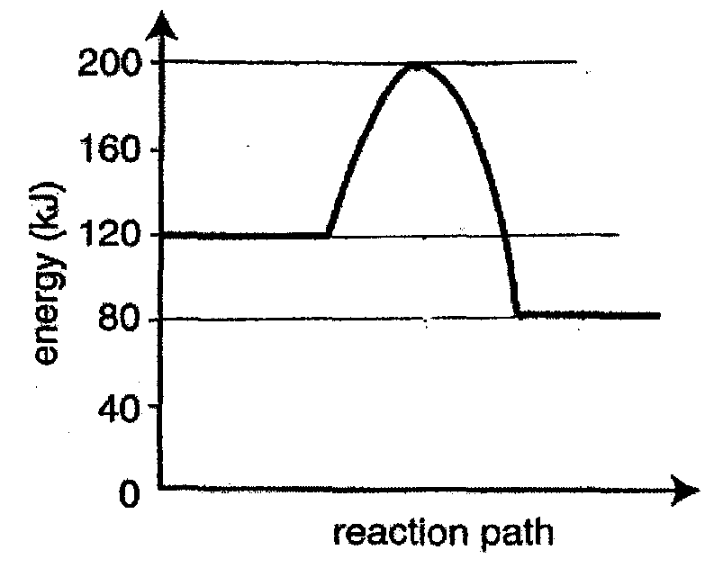

(a) Determine the activation energy for the reaction? [1]
(b) Determine the enthalpy for the reaction? [1]

Question 23 ( 5 marks)

The reaction between dilute solutions of HCl and Na₂S₂O₃ can be readily observed, as a precipitate of sulfur is produced.
The following results were obtained when different concentrations of Na₂S₂O₃ were reacted
with 5 mL of 3 mol L⁻¹ HC1.
Note: the total volume of the solution is 25 mL in each case.

Volume of  0.15 mol.L^{-l}  Na₂S₂O₃  (mL) | Volume of  H₂O added  (mL) | Volume of  HCl added  (mL) | Concentration of  Na₂S₂O₃  (mo1.L⁻¹) | Reaction time  (s)
20 | 0 | 5 | 0.12 | 13.1
15 | 5 | 5 |  | 16.1
10 | 10 | 5 |  | 24.0
5 | 15 | 5 |  | 37.0

(a) Complete the table above by filling in the entries for Na₂S₂O₃ concentration. [1]
(b) On the graph paper provided , plot the reaction times against Na₂S₂O₃ concentration. [2]
(c) What generalization can you make about the relationship between Na₂S₂O₃ concentration and the reaction time? [1]
(d) Predict the reaction time for a Na₂S₂O₃ concentration of 0.04 mol L⁻¹. [1]

